**AMERICAN INTERNATIONAL UNIVERSITY-BANGLADESH**

**Faculty of Science and Technology**



**Course Title: Data Communication**

**Lab Report-2**

|  |  |
| --- | --- |
| ***Submitted by:***  **Name: Shifat, Shadril Hassan**  **ID: 20-42451-1**  **Section: G**  **Program: BSc CSE**  **Semester: Spring 2021-2022**  **Date: 19 February, 2022** | ***Submitted to:***  **Course Teacher: Tanjil Amin** |

Class Task:Similar task can be done where we use a composite signal instead of signals x1 and x2. Suppose  
our composite signal is  
signal_x = a1*sin(2*pi*f1*t) + a2*cos(2*pi*f2*t);  
Here, a1 = (B + G + H), a2 = (C + E + H), f1 = (G + H + 2), and  
f2 = (E + F+ H). [Assume your ID is AB-CDEFG-H]

*****Show this signal both in time domain and frequency domain.

MATLAB Code:

clc;

clear all;

close all;

A=2;

B=0;

C=4;

D=2;

E=4;

F=5;

G=1;

H=1;

a1= B+G+H;

a2= C+E+H;

f1= G+H+2;

f2= E+F+H;

fs = 1000; %sampling frequency

t = 0:1/fs:2; % time array

signal_x = a1*sin(2*pi*f1*t) + a2*cos(2*pi*f2*t);

% time domain representation

figure;

plot(t,signal_x,'b','linewidth',1.5);

xlabel('time');

ylabel('amplitude');

title('time domain representation of signal x');

% frequency domain representation

fx = abs(fftshift(fft(signal_x)))/(length(signal_x)/2);

freq = linspace(-fs/2, fs/2, length(signal_x));

figure;

bar(freq, fx,'r','linewidth',1);

xlim([-15 +15]);

xlabel('frequency');

ylabel('amplitude');

title('frequency domain representation of signal x')

**Output:**

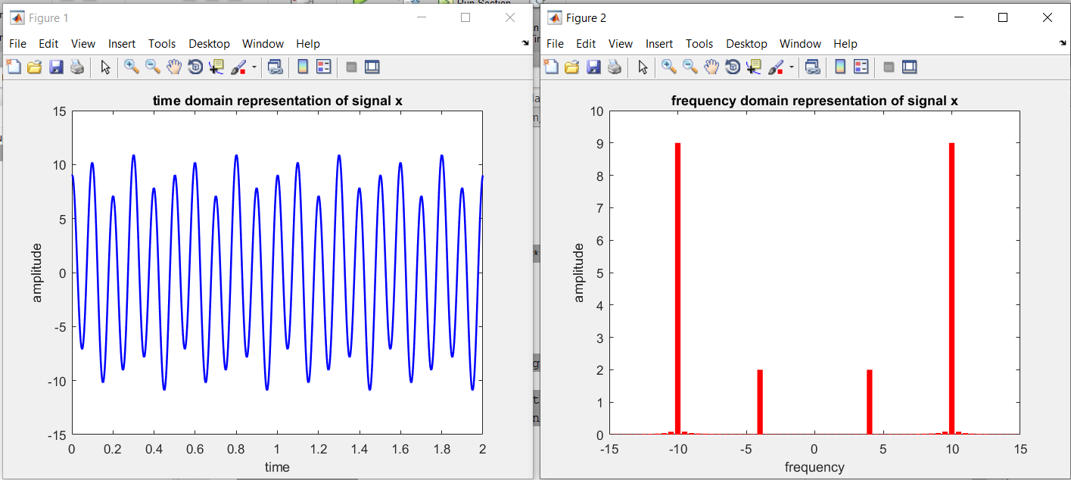

**Performance Task for Lab Report: (your ID = AB-CDEFG-H)**

**Generate a composite signal using three simple signals as,

x1 = a1*cos(2*pi*f1*t), x2 = a2*sin(2*pi*f2*t), x3 = a3*cos(2*pi*f3*t)  
signal_x = x1 + x2 + x3

Select the values of the amplitude and frequency as follows: a1 = A + C + 1, a2 = A + D + 2, a3  
= A + E + 1, f1 = A + E + 1, f2 = A + D + 2, f3 = A + C + 1.

**(a) Show time domain and frequency domain representations of signal_x in a single figure window using subplot. Use axis, or xlim, or ylim to appropriately represent the signal.**

**MATLAB Code:**

clc;

clear all;

close all;

A=2;

B=0;

C=4;

D=2;

E=4;

F=5;

G=1;

H=1;

a1= A+C+1;

a2= A+D+2;

a3= A+E+1;

f1= A+E+1;

f2= A+D+2;

f3= A+C+1;

fs = 1000; %sampling frequency

t = 0:1/fs:2; % time array

x1= a1*cos(2*pi*f1*t);

x2= a2*sin(2*pi*f2*t);

x3 = a3*cos(2*pi*f3*t);

signal_x= x1+x2+x3;

% Question (a)

% time domain representation

subplot(2,1,1);

plot(t,signal_x,'b','linewidth',1.5);

xlabel('time');

ylabel('amplitude');

title('time domain representation of signal x');

% frequency domain representation

fx = abs(fftshift(fft(signal_x)))/(length(signal_x)/2);

freq = linspace(-fs/2, fs/2, length(signal_x));

subplot(2,1,2);

bar(freq, fx,'r','linewidth',1.5);

xlim([-15 +15]);

xlabel('frequency');

ylabel('amplitude');

title('frequency domain representation of signal x');

**Output:**

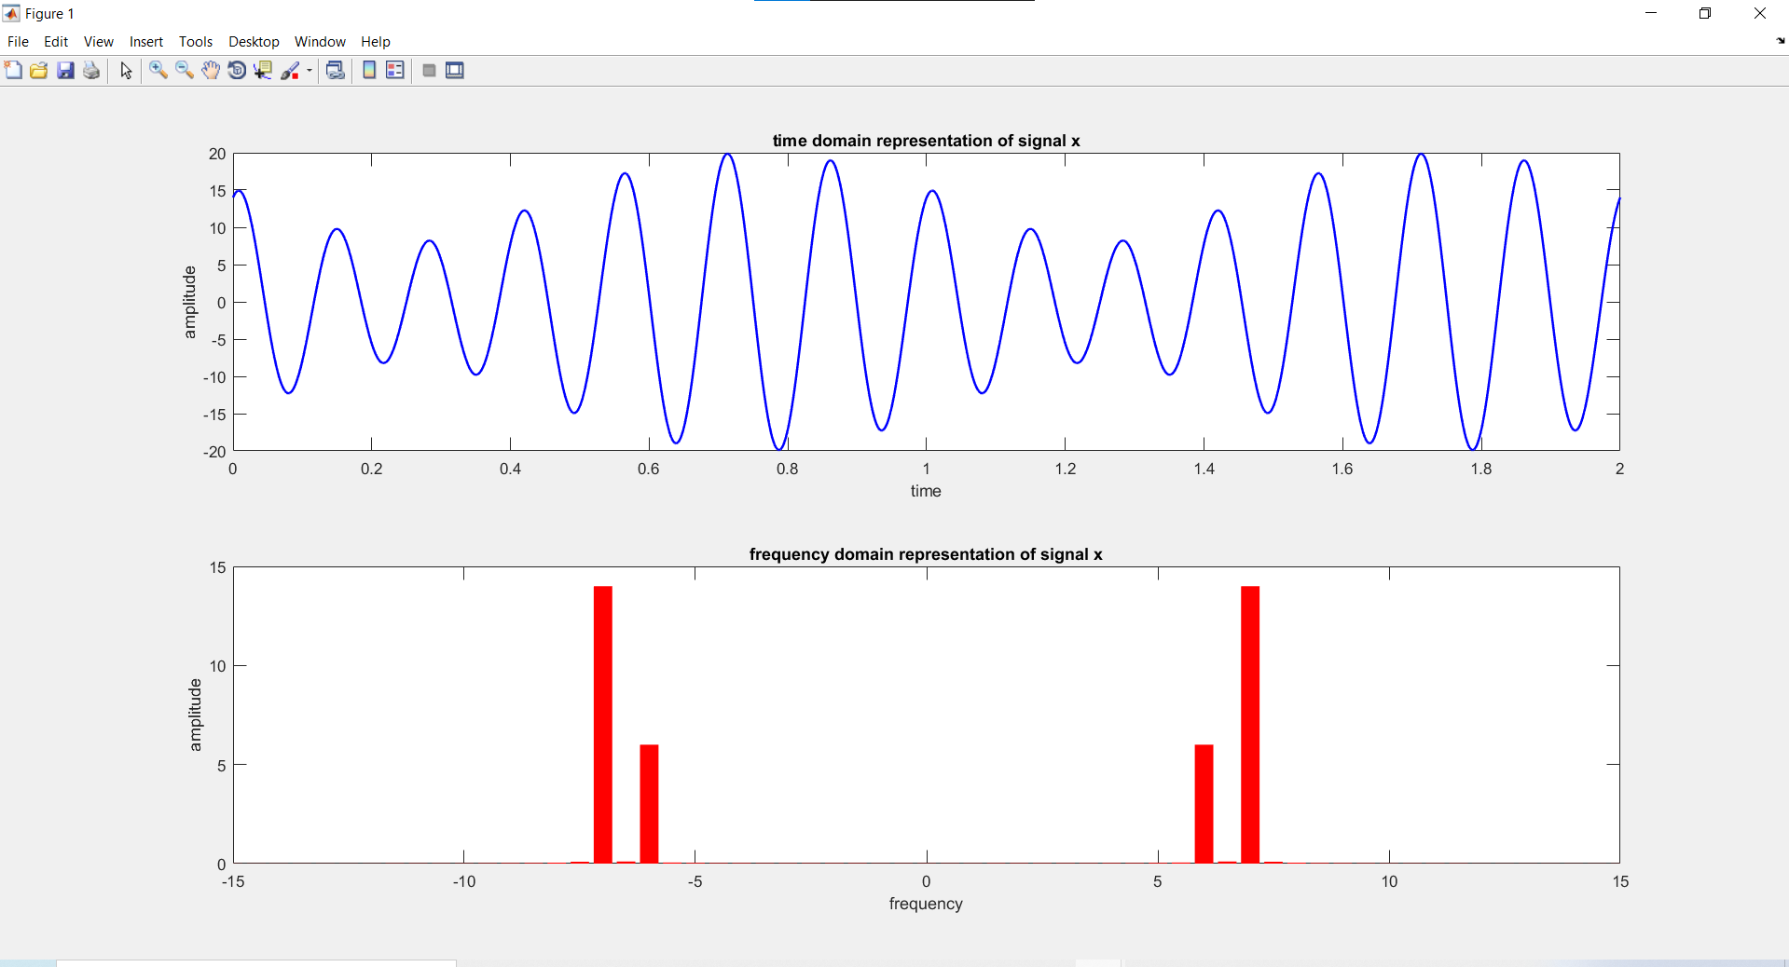

**(b) Quantize signal_x in 8 equally distributed levels and provide image for one cycle of the  
original signal and quantized signal. Use axis, or xlim, or ylim to appropriately represent the signal.**

**MATLAB Code:**

clc;

clear all;

close all;

A=2;

B=0;

C=4;

D=2;

E=4;

F=5;

G=1;

H=1;

a1= A+C+1;

a2= A+D+2;

a3= A+E+1;

f1= A+E+1;

f2= A+D+2;

f3= A+C+1;

fs = 1000; %sampling frequency

t = 0:1/fs:1; % time array

x1= a1*cos(2*pi*f1*t);

x2= a2*sin(2*pi*f2*t);

x3 = a3*cos(2*pi*f3*t);

signal_x= x1+x2+x3;

% Question (b)

p= linspace(-15,15,7);

c= linspace(-20,20,8);

[i,q]= quantiz(signal_x,p,c);

plot(t,signal_x,'*',t,q,'x','linewidth',1.5);

xlabel('time');

ylabel('amplitude');

title('quantization using quantiz() of signal x');

legend('signal x','quantized signal x');

**Output:**

